Temasek Polytechnic

School of Informatics & IT

**Database Application Development (CAA1C03)**

**AY 20/21 Oct Semester**

**Project Part 2**

**(Database Design)**

|  |  |
| --- | --- |
| Name: | Khemani Luv Ashok |
| Admission Number: | 2071541c |
| Class: | P01 |

Table of Contents

Introduction 3

The Entity-Relationship Diagram 4

Data Dictionary 5

# Introduction

Eat Eat Happy is a curated restaurant review website with user submitted reviews. It provides a one stop destination to decide on where to dine for your next meal. Users can search by restaurant names, cuisine type, browse a map to locate restaurants near their desired location as well as check out registered user submitted reviews. Each restaurant features multiple photographs of the venue and menu items, address, contact number and opening hours.

# The Entity-Relationship Diagram

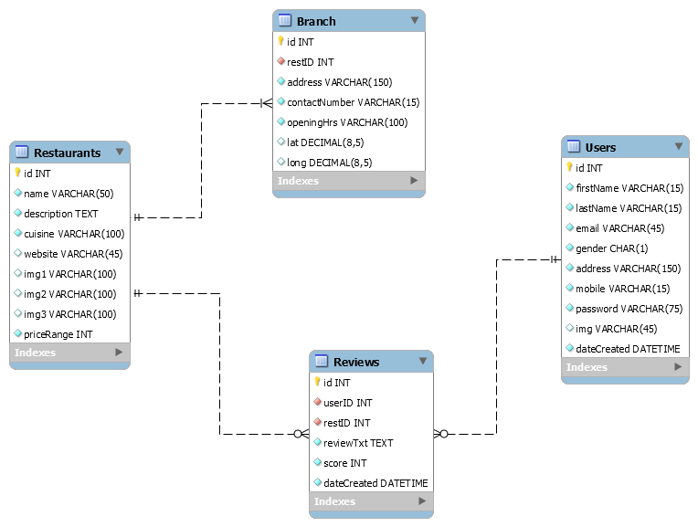

# Data Dictionary

|  |  |  |  |  |  |  |
| --- | --- | --- | --- | --- | --- | --- |
| **Table: Restaurants** | | | | | | |
| Table Comments | List of restaurants | | | | | |
| Columns | | | | | | |
| **Name** | **Data Type** | **Not Null** | **PK** | **FK** | **Unique** | **Description** | **Example** |
| id | INT | Yes | Yes | No | Yes | Restaurant Unique ID | 43 |
| name | VARCHAR(50) | Yes | No | No | No | Name of Restaurant | Lovehandle Burgers |
| description | TEXT | Yes | No | No | No | Restaurant Description | Come dine at the best burger restaurant in Singapore! |
| cuisine | VARCHAR(100) | Yes | No | No | No | Type of Cuisine (comma separated) | Western,Local |
| website | VARCHAR(45) | No | No | No | No | Restaurant URL | http://www.lovehandleburgers.com.sg |
| img1 | VARCHAR(100) | No | No | No | No | Restaurant image 1 | http://www.lovehandleburgers.com.sg/img/1.jpg |
| img2 | VARCHAR(100) | No | No | No | No | Restaurant image 2 | http://www.lovehandleburgers.com.sg/img/2.jpg |
| img3 | VARCHAR(100) | No | No | No | No | Restaurant image 3 | http://www.lovehandleburgers.com.sg/img/13.jpg |
| priceRange | INT | Yes | No | No | No | Cost range of dishes //1-5 | 3 |

|  |  |  |  |  |  |  |  |
| --- | --- | --- | --- | --- | --- | --- | --- |
| **Table: Users** | | | | | | | |
| Table Comments | | User list | | | | | |
| Columns | | | | | | | |
| **Name** | **Data Type** | | **Not Null** | **PK** | **FK** | **Unique** | **Description** | **Example** |
| id | INT | | Yes | Yes | No | Yes | User ID | 3 |
| firstName | VARCHAR(15) | | Yes | No | No | No | First name of User | Lim |
| lastName | VARCHAR(15) | | Yes | No | No | No | Last Name of User | Ko Pi |
| email | VARCHAR(45) | | Yes | No | No | Yes | User email address | kopi@singnet.com.sg |
| gender | CHAR(1) | | Yes | No | No | No | User gender | M |
| address | VARCHAR(150) | | Yes | No | No | No | User address | 11 Kopi Rd, #01-23 Singapore 113344 |
| mobile | VARCHAR(15) | | Yes | No | No | No | User mobile number | +6582346574 |
| password | VARCHAR(75) | | Yes | No | No | No | User password, SHA256 encoded for security | 5fd924625f6ab16a19cc9807c7c506ae1 813490e4ba675f843d5a10e0baacdb8 |
| img | VARCHAR(45) | | No | No | No | No | User profile image filename | Spongebob.png |
| dateCreated | DATETIME | | Yes | No | No | No | Date Registered | 2020-12-1 17:23:12 |

|  |  |  |  |  |  |  |
| --- | --- | --- | --- | --- | --- | --- |
| **Table: Branch** | | | | | | |
| Table Comments | Branches of Restaurants | | | | | |
| Columns | | | | | | |
| **Name** | **Data Type** | **Not Null** | **PK** | **FK** | **Unique** | **Description** | **Example** |
| id | INT | Yes | Yes | No | Yes | Branch ID | 12 |
| restID | INT | Yes | No | Yes | No | Parent Restaurant ID | 23 |
| address | VARCHAR(150) | Yes | No | No | No | Branch Address | 11 Bedok South Rd, #01-01 Singapore 118923 |
| contactNumber | VARCHAR(15) | Yes | No | No | No | Branch Contact number | +6587234532 |
| openingHrs | VARCHAR(100) | Yes | No | No | No | Opening hours encoded in special format //Syntax : //[Day]:[Open],[Close];…. | 1:1000,1700; 2:1000,1700; 3:1000,1700; 4:1000,1700; 5:1200,2300;  6:CLOSED; 7:1000,1700; |
| lat | DECIMAL(8,5) | No | No | No | No | Latitude of branch | 1.0234 |
| long | DECIMAL(8,5) | No | No | No | No | Longitude of branch | 31.2304 |

|  |  |  |  |  |  |  |
| --- | --- | --- | --- | --- | --- | --- |
| **Table: Reviews** | | | | | | |
| Table Comments | List of reviews. (userID and restID are a grouped unique constraint to ensure only 1 review per user for each restaurant) | | | | | |
| Columns | | | | | | |
| **Name** | **Data Type** | **Not Null** | **PK** | **FK** | **Unique** | **Description** | **Example** |
| id | INT | Yes | Yes | No | Yes | Review ID | 12 |
| userID | INT | Yes | No | Yes | Yes | User ID who submitted review | 23 |
| restID | INT | Yes | No | Yes | Restaurant ID of which review is written for | 21 |
| reviewTxt | TEXT | Yes | No | No | No | Review Text, formatted as follows //[Heading]:[body] | Great Food for a great price:I went down to this place because a friend recommended it. I was not expecting much but was blown away by the quality of the food and service. Highly recommend!! |
| score | INT | Yes | No | No | No | Review score from 1-5 | 5 |
| dateCreated | DATETIME | Yes | No | No | No | Date Review was submitted | 2020-12-1 17:23:12 |